Jennifer DeVore

16 March 2020

CIS 435

**Unit 3 Graded Exercise 2: Using Functions**

**1. Write a SELECT statement that returns two columns based on the Vendors table. The first column, Contact, is the vendor contact name in this format: first name followed by last initial (for example, “John S.”) The second column, Phone, is the VendorPhone column without the area code. Only return rows for those vendors in the 559 area code. Sort the result set by first name, then last name.**

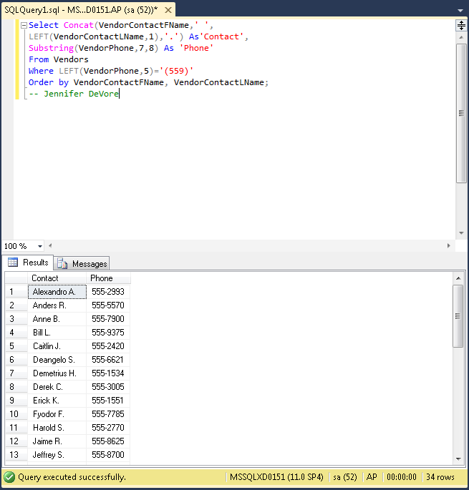

**2. Write a SELECT statement that returns the InvoiceNumber and balance due for every invoice with a non-zero balance and an InvoiceDueDate that’s less than 30 days from today.**

